**Why do farmers sell immediately after harvest when prices are lowest?**

***Design of the Interventions***  
Joachim De Weerdt, Brian Dillon, Emmanuel Hami, Bjorn Van Campenhout, Leocardia Nabwire

# **Outline of the document**

Specific details of the treatments/interventions are presented, and later, the general implementation approach.

# **Introduction**

Farmers opt to sell immediately after harvest for several reasons. The current study seeks to empirically test three hypotheses, namely:

1. Budget neglect--- forgetting some future expenditures when deciding on how much to sell immediately after harvest.
2. Cognitive burden of planning--- farmers have insufficient information or limited understanding of future scenarios, hence they find it easy doing what they have always done and what they see others around them do, which may include selling immediately post-harvest.
3. Incorrect beliefs about price cycles, possibly because farmers are overly adaptive (i.e, they anchor too much on recent years' prices).

# **The treatments to test the above 3 hypotheses**

1. Expenditure plan (T1): --- Guide 1123 farmers to develop a detailed budget for future expenditures until the next harvest.
2. Sales/income plan (T2): --- Guide 1123 farmers to develop a detailed plan for selling the targeted crops until the next harvest.
3. Provide historical price information (T3): --- 1123 farmers
4. Plus, a control group: --- 1123 farmers

Are these still the sample sizes?

## **1st Treatment:** **Farming households develop a detailed expenditure budget**

The intervention seeks to test the hypothesis farmers sell immediately after harvest due to budget neglect--- forgetting or underestimating future expenditures when deciding on how much to sell immediately after the harvest.

Budget neglect may make farmers overoptimistic about the future, hence selling more/overconsumption right after harvest.

Example of budget neglect--- farmer may budget for fresh seed from the agro-input dealer and for fertilizer, but they may forget that’ll they also need pesticides for the next planting season.

The intervention will draw farmers’ attention to otherwise neglected expenditure budget items through three approaches, and 4 steps (Figure 1).

Figure 1: Implementation steps for T2

The result of the budgeting process is an expenditure budget as structured in Table 1 below.

Table 1: Template for the expenditure budget

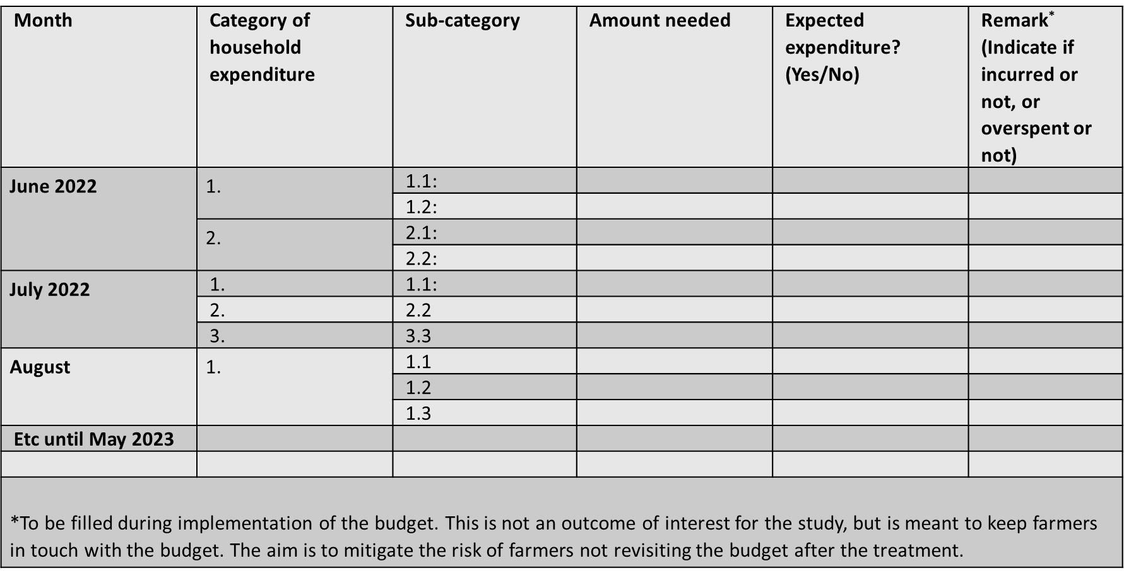

## **2nd Treatment: Farmers develop a sales plan, linked to future expenses as a commitment tool**

The second treatment hypothesizes that farmers opt to sell all or most their crop harvest immediately post-harvest due to the cognitive burden of planning (insufficient information or limited understanding of future scenarios, hence they find it easy doing what they have always done and what they see others around them do). The cognitive burden of planning, coupled with present bias, may lead farmers to sell a bulk of their crop at once, right after harvest, even when there is no immediate expenditure that needs to be financed.

To test the second hypothesis, we will take farmers through a detailed process of developing a sales/income plan in which farmers make explicit when to sell how much of maize, soybeans and groundnuts. For cognitive ease, and as a commitment tool, the treatment will also require farmers to link the timing and quantity of sales to future expenditures that they think will be financed by the income from each given sale.

The key element of the treatment is to encourage farmers to match the timing of crops sales to the timing of expenditures, and thus be able to defer sales and benefit from the opportunities of intertemporal arbitrage.

*Example 1*: If a households will need to sell a total of 6 bags of maize to pay for 3 school terms expenses (e.g in Sept 2022, Jan 2023 & May 2023--- meaning 2 bags per term), the treatment would encourage the farmer to plan to sell 2 bags in the respective months/terms, instead of selling all the 6 bags at once immediately after harvest (and keep the cash until time for paying school expenses).

*Example 2*: If a farmer plans to sell 1 bag of groundnuts to buy seed/fertilizer in Jan 2023 for the next planting season, he should plan to sell the bag of groundnuts in Jan when he needs to buy the seed/fertilizer.

The above two examples are for known future expenses. In the case of unexpected expenditures, the treatment will require farmers to a allocate a share of the total harvest to unexpected expenditures, and then divide this portion into 4 equal parts to be sold quarterly, or plan to sell only when the emergency arises.

**Process of developing the sales plan**

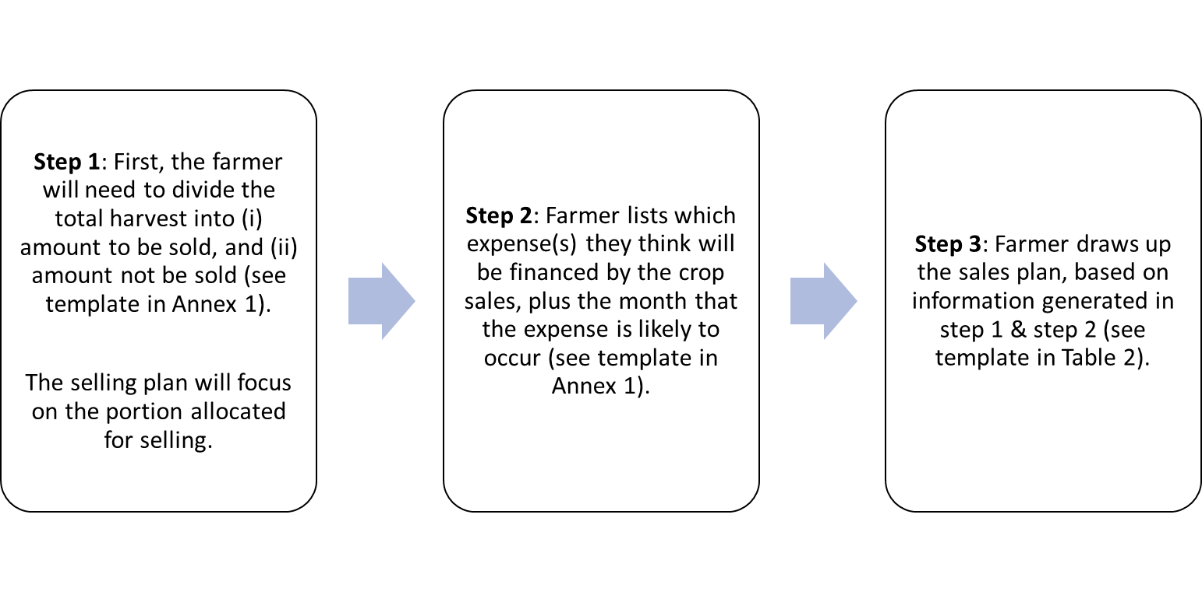

The result of the planning process is a sales plan as structured in **Error! Reference source not found.** below.

Table 2: Template for the sales/income plan

|  |  |  |  |
| --- | --- | --- | --- |
| Month/year | Crop to be sold | Quantity | Expenditure to be financed |
| June 2022 | Maize | 1 bag | Household supplies for 3 months & Loan repayment. |
| Soybean | 1 bag | Investment in animals (e.g buying an extra goat) |
|  | Groundnuts | ½ bag |  |
| July 2022 | - | - | - |
| August 2022 | - | - | - |
| September 2022 | Maize | 2 bags | School expenses for term 3 |
|  | Ground nuts | 1 bag | School expenses for term 3 |
| Etc |  |  |  |

## **3rd Treatment: Providing historical price information to 1123 farming households**

The treatment is based on the assumption that farmers have incorrect beliefs about price cycles, possibly because they are overly adaptive, i.e. they anchor too much on recent years' prices.

To test this hypothesis, the study will implementation an intervention where we provide farmers with historical (5 years) monthly price movements for maize, soybean and Groundnuts. The price data will be for the markets in the study districts and the neighboring markets. Price data will be obtained from the Malawian Agricultural Commodity Exchange (ACE).

**Implementation of the treatment**

Historical price information will be presented to farmers in form of charts and figures on a piece of paper. After implementation of the treatment, the farmer will be allowed take the paper home for future reference.

# **The treatments: general implementation guidelines**

**When**: The treatments will be embedded in the baseline survey with household head/person(s) responsible for most decisions about household expenditures and incomes. The survey is scheduled to take place from mid-May to mid-June 2022.

**How**: The treatments will be administered per household, in the local language, by Research Assistants who will have been trained on the implementation of each treatment. A pre-test will be conducted prior to the actual implementation. Each treatment will be implemented only once during the entire study period.

**Where**: in 113 villages in the Central and Northern Region of Malawi (Kasungu, Mzimba, Ntchisi, Rumphi, Dowa and Mchinji). In each village, 30 treatment and 10 control farmers will be studied.

**General process for implementing the treatments.**

1. Participatory and farmer driven. The Research Assistant only facilitates; no coaching. This enhances ownership & the chances of implementing the plan.
2. In their respective treatment groups, a treated farmer will first be taken through the study objectives, and the importance of making the respective budgets/plans, in the context of marketing the target crops.
3. The farmer will then be guided to develop the budget/plan using a sequence of predetermined steps for each treatment.
4. Each farming household will be provided with a book--- for rough work, and a standardized budget/plan template for recording the final budget/plan.

**Mitigating potential risks after the administration of the treatments**

* There is a likelihood that some farmers will not make use of the budgets/plans.
* To mitigate against this risk, farmers will be encouraged to record the actual expenditures or incomes or both against the planned expenditures/income for every month. This exercise will encourage the treated farmers to remain in touch with their developed budget/plan.
* The records of actuals against what was budgeted/planned will be checked at endline.

**Annex 1: Template: Farmer apportions the total harvest between amount not to be sold, and to be sold**

|  |  |  |
| --- | --- | --- |
| Crop |  | Amount (bags) |
| Maize | 1. Total amount of harvest (bags): | e.g 10 |
| 1. Not to be sold (home consumption + gifts till next harvest) | e.g 2 |
| 1. To be sold: | e.g 8 |
| 1. For known expenses (till next harvest) | e.g 6* |
| 1. For unexpected expenses (till next harvest) | e.g 2* |
|  | | |
| Soybean | 1. Total amount of harvest (bags): | e.g 10 |
| 1. Not to be sold (home consumption + gifts till next harvest) | e.g 2 |
| 1. To be sold: | e.g 8 |
| 1. For known expenses (till next harvest) | e.g 6* |
| 1. For unexpected expenses (till next harvest) | e.g 2* |
|  | | |
| Groundnuts | 1. Total amount of harvest (bags): | e.g 10 |
| 1. Not to be sold (home consumption + gifts till next harvest) | e.g 2 |
| 1. To be sold | e.g 8 |
| 1. For known expenses (till next harvest) | e.g 6* |
| 1. For unexpected expenses (till next harvest) | e.g 2* |

*The selling plan will focus on these quantities.

**Annex 2: Template--- household expenses that will be financed by income from crop sales**

|  |  |  |
| --- | --- | --- |
| Crop | Intended expenditure | When is the expenditure likely to occur |
| Maize | Expense 1:  e.g, school expenses (fees, uniform, books) for 3 school terms. | September 2022, January 2023, and 2023. |
| Expense 2:  e.g Fertilizer for the next planting season starting in February 2023 | January 2023 |
| Expense 3:  e.g Household expenses (bills, soap, salt, sugar, etc) | June 2022 to May 2023 |
| Expense 4: | - |
| Soybean | Expense 1: |  |
| Expense 2: |  |
| Expense 3: |  |
| Ground nuts | Expense 1: |  |
| Expense 2: |  |